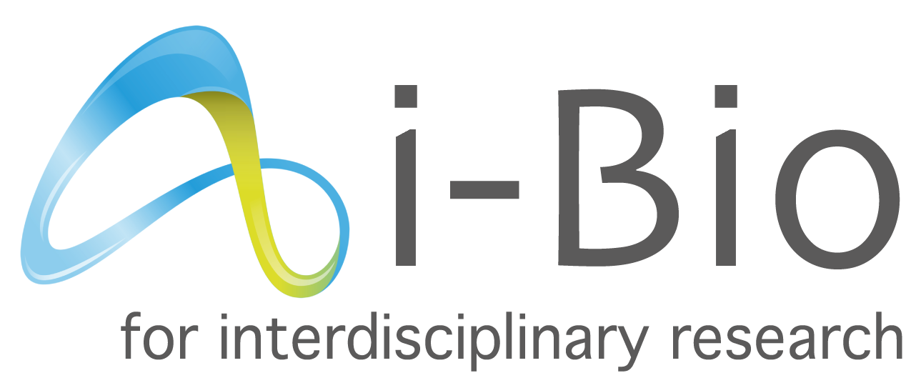

Call for Interdisciplinary Projects 2022
Application deadline : January 6, 2022

Information about the project coordinator

Title of the project :

Name, first name :
Email :
Phone :
Title/Employer :
Address :
Laboratory :
Title of the team :
Team leader(s) (if différent) or co-leader (if applicable) :

People involved in the project, apart from the coordinator (do not mention names)

 | Number | % of time spent on the project
Statutory researchers/teachers-researchers
Post-doctoral fellows
PhD students (mention the year in which the thesis was started)
ITA/BIATSS

Possible resources already obtained on the proposed project (indicate the sources, amounts and dates)

Team collaborations (since 2018 and ongoing ; mention those involving the coordinator)

Main publications of the coordinator since 2016 (10 maximum, name of the coordinator in bold, use the format below)
Barnes R., Hoods T., Dams Y., Dupont J. and Norris K. (2019). The Ca²⁺-activated channel Rhips2 controls microvilli length in leukemia cells. J. Cell Sci. 242, 3742-3753.

Key words (5 max)

Information about the partner

Name, first name :
Email :
Phone :
Title/Employer :
Address :
Laboratory :
Title of the team :
Team leader(s) (if différent) or co-leader (if applicable) :

People involved in the project, apart from the partner (do not mention names)

 | Number | % of time spent on the project
Statutory researchers/teachers-researchers
Post-doctoral fellows
PhD students (mention the year in which the thesis was started)
ITA/BIATSS

Possible resources already obtained on the proposed project (indicate the sources, amounts and dates)

Team collaborations (since 2018 and ongoing ; mention those involving the partner)

Main publications of the project partner since 2016 (10 maximum, name of the coordinator in bold, use the format below)
Barnes R., Hoods T., Dams Y., Dupont J. and Norris K. (2019). The Ca²⁺-activated channel Rhips2 controls microvilli length in leukemia cells. J. Cell Sci. 242, 3742-3753.

Key words (5 max)

Project

Title:

Abstract (250 words max):

Project (2500 words max, 1.5 line spacing, font size 12, up to 10 Mo file size):
- Context:
- State of the art:
- Objectives:
- Methodology:

Implementation planning (250 words max):

Added value and complementarity of the consortium, relevance to the expected outcomes of the i-Bio call (400 words max):

Requested means by item of expenditure and by partner:
 | Partner 1 | Partner 2
Staff expenses
Scientific consumables
-
-
…
Instruments and material costs
-
-
…
Outsourcing / subcontracting
-
-
…
Travel costs
-
-
…
Sub-total
Total

Please name your pdf file:
NAME(coordinator)_iBIO_SUBV_2022

To be sent to sciences-ibio@sorbonne-universite.fr
title of the mail: application to i-Bio – NAME(coordinator)
before January 6, 2022 at midnight

